Project: Woodson Park Academy & YMCA-ELC
Week Ending: September 13th, 2019

THIS WEEK:
- Foundation wall crew mobilized
- Grading ongoing
- Storm line install ongoing
- Installed lower detention pond

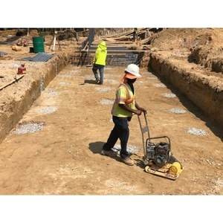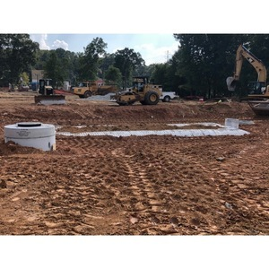

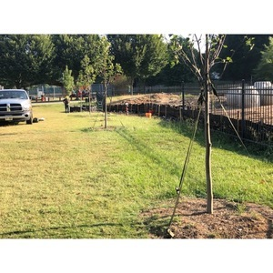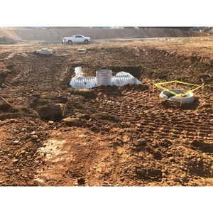

NEXT WEEK – September 15 thru September 20:
- Foundations
- Temp power
- Grading

PAYMENT STATUS:
- Gmp#1 $3,703,488.00
  - Paid to date amount $646,892.85
- GMP#2 $28,686,295.00
  - Paid to date amount $0.00

SCHEDULED DATE OF SUBSTANTIAL COMPLETION
- WPA – September 28, 2020
- YMCA-ELC - September 16, 2020

PREPARED BY:
- Matt Dauber, Carroll Daniel Construction Co.

